COS30049 - Computing Technology Innovation Project

Assignment 1 for Group Set 1

Design Document

Group: 1.1

Contents

1. Project background and introduction 3

2. Team Introduction 4

3. Project requirement list and description 5

*Users can view digital assets available for trading:* 5

*All the listed digital assets information should be stored in the database:* 5

*The system should provide a search and filter functionality for users to discover specific assets of interest:* 5

*The website will implement smart contracts to act as escrow during the trading process, and smart contracts should ensure that assets are held securely until the trade is completed or canceled:* 6

*Users should have access to a transaction history to view their past trades:* 6

4. Project design 7

*Overall system architecture design* 13

*Front-end interface: 13

*Back-end security and functionality: 13

5. Refences*:* 14

# Project background and introduction

Decentralized exchanges, commonly known as DEXs, are peer-to-peer platforms where cryptocurrency traders make transactions directly, bypassing the need for intermediaries to manage their funds. Our outstanding project is the creation of a blockchain-based web platform that allows traders to purchase and trade exclusive NFTs representing used balls from famous, top-tier football players from all over the world or from famous football matches. This website aims to cater to superfans who want to have a chance to own a unique, one-of-a-kind NFT-football in a secure and transparent marketplace. This concept aligns well with the functionality of NFTs, which are unique digital assets stored on a blockchain, each with distinct attributes and ownership records.

Imagine being able to own a ball that Lionel Messi or Kylian Mbappe played with and scored in a World Cup Final, or the ball that was caught by Gianluigi Buffon in a Champions League Final. These balls are often used only once in a game and are never used again in any match. Recognizing the needs of top sports fans, the website seeks to revolutionize this by using blockchain technology and smart contracts to offer these special items as non-fungible tokens (NFTs) on the blockchain and interested buyers can acquire them using cryptocurrency.

* *Key feature of the Football Marketplace:*

***Smart Contracts*:** Utilizes smart contracts to automate and enforce the terms of transactions between buyers and sellers. Smart contracts ensure that once conditions are met, such as payment, the ownership transfer of the NFT is executed automatically, providing security and trust in the transaction process.

***Cryptocurrency Payments***: The marketplace will facilitate transactions using cryptocurrencies, making it convenient and secure for both buyers and sellers.

***Unique Memorabilia***: Users have the opportunity to own unique memorabilia associated with significant moments in football history, that make the buyer the exclusive ownership of the ball.

***Peer-to-Peer Transactions***: Users can engage in peer-to-peer transactions, enhancing efficiency and reducing costs associated with traditional marketplaces.

***Transparency and Audibility***: Ensures transparency and audibility in the marketplace operations by providing access to transaction history and your own e-wallet. Users can make informed decisions based on real-time information.

# Team Introduction

All talented members of our team share a passionate dedication to revolutionizing the sports memorabilia industry through blockchain technology, NFTs, and decentralized exchanges. Together, we are committed to delivering excellence and positive outcomes in every aspect of our work.

1. Nguyen Canh Giang

First of all, our acclaimed project leader, Nguyen Canh Giang, is a key member of our team due to his considerable experience with blockchain technology and NFTs. Giang's extensive experience in these fields allows him to offer priceless insights and knowledge that will help our project succeed.

1. Do Quang Minh

Do Quang Minh is a tremendous asset to our team due to his profound knowledge of decentralized finance and blockchain technology. This knowledge guarantees the smooth integration and optimization of decentralized exchange features within our project.

1. Nguyen Duy Anh

Our amazing interface and user experience designer is Nguyen Duy Anh. Duy Anh takes our project to the next level with his creative approach to designing user-centric experiences. He has an eye for detail and is passionate about producing intuitive designs.

1. Doan Trung Nghia

Doan Trung Nghia has a strong interest in innovation and is a master coder. He is essential to the design and execution of reliable smart contracts, which guarantee the safety and effectiveness of our blockchain-based platform.

1. Pham Hoang Duong

Our renowned football specialist and relationship checker is Pham Hoang Duong. He is a crucial contributor to our project's success because of his extensive knowledge of the football world and his ability to form strategic connections. He also ensures that our project stays in line with industry developments by fostering important collaborations.

# Project requirement list and description

## *Users can view digital assets available for trading:*

Users can access the website through login or sign up if they don’t have an account yet. Our web provides clear and comprehensive information about each ball digital asset, including its image and a special player associated with the ball.

**Description**: The platform will offer a catalog of exclusive balls from big matches in football history. Each ball description will be unique because it has been used in a different match. It may include information like brand name, production date, date of the match it was played in and the name of the match.

## *All the listed digital assets information should be stored in the database:*

The ball information will be securely stored in a blockchain database, leveraging blockchain technology to ensure the authenticity, integrity, and immutability of the stored data. Blockchain's decentralized and distributed ledger system enhances security and transparency, making it an ideal solution for storing valuable asset information like exclusive footballs from significant matches in football history. This approach not only protects the integrity of the data but also fosters trust among users by providing a verifiable and tamper-proof record of each ball's details.

**Description:** All this data will be securely stored in a blockchain database. Users can access and explore to these balls, making better decisions about their purchases.

## *The system should provide a search and filter functionality for users to discover specific assets of interest:*

Users can utilize a search bar to input specific keywords, such as player names, match titles, or ball brands, to find relevant digital assets.

The search algorithm scans through the database and returns results that match the user's request, displaying relevant assets based on their information they fill.

**Description**: Users have the option to filter assets using various criteria, such as player name: enables users to narrow down resources linked to particular football players, match date: enables users to sort assets according to the day the ball was used in a football game, ball brand: enables users to filter resources based on the football's brand, match title: assists users in sorting assets according to the football match's name or title.

## *The website will implement smart contracts to act as escrow during the trading process, and smart contracts should ensure that assets are held securely until the trade is completed or canceled:*

Smart contracts are essential to the security of ball purchases because they act as a virtual escrow. Only when specific conditions are met can these self-executing transactions take place. This reduces the possibility of fraud and theft occurring during the trading process, giving customers confidence that their funds are safeguarded by the immutable ledger of the blockchain. The smart contract can immediately cancel the deal and restore the assets to each of their separate owners if the conditions are not completed within the allotted time.

**Description**: A smart contract will start when a user chooses to buy a ball. To guarantee the security and integrity of the purchasing process, the smart contract will retain ownership of the ball in escrow until all transactional requirements are done.

## *Users should have access to a transaction history to view their past trades:*

Users are able to monitor their trading activities by accessing their transaction history and reviewing previous transactions. Users that have transparent access to their transaction history are more confident and trustworthy since they can confirm the accuracy of their records and confirm the facts of their transactions.

**Description**: The transaction history acts as an audit trail by recording the specifics of every trade, such as the date and time of the trade, the assets that were exchanged, the counterparties that were involved, and the transaction status (completed, pending, or canceled).

Users can ensure proper record keeping and financial transparency by consulting their transaction history for regulatory compliance needs, tax reporting, or accounting purposes.

# Project design

## *Overall system architecture design*

### *Front-end interface:

The entire web interface is providing an engaging user experience, with essential details of the NFT ball such as the name or match of the player associated with the ball. The user interface also introduces a search bar, allowing users to view the NFTs they love and choose to purchase it. The range of balls is so diverse that sports fans will have plenty of options to get involved and find the ball that suits their preferences.

The user interface is integrated with blockchain technology: when the ball is added to the user's cart, they can view the transaction directly from the interface. These transactions are performed through smart contracts, which are the core of the system. It plays an important role to ensure every ball a user pays for is one of a kind and the user will have full permission to use the ball.

### *Back-end security and functionality:

The application server hosts the backend logic and business processes of the football market.

It handles user requests, processes data, and communicates with external services and databases. Stores and manages structured data related to users, balls, transactions, and other related system entities. Use smart contracts to manage escrow, transfer ownership, and validate transactions securely and transparently.

It is using best practices to encrypt data and in transit to protect sensitive information for users as well as their transaction data.

## *Front-end Prototype*

Navigation buttons

Go to your e-wallet

*Figure 1: Home page*

Go directly to the store page

Our social media

Our home page appeals to the average sports fan because the layout is so simple but very effective. It is a clean site with a flawless look, someone without any technical background could use it easily. You will feel as if you are in good hands and you know that you will be able to find any ball you need on this website.

At the top of the page is a simplified navigation button, ensuring that customers can explore the site effortlessly. Below that is a huge image that grabs the attention of any top sports fan, featuring a picture of a famous football player with a concise message. Users can go directly to the store page or exchange cryptocurrency based on their preference right now.

The footer of the page contains our information and essential link, offering users access to our social media pages for upcoming news, contact detail and copyright notices.

Navigation bar

Ball name with its image

*Figure 2: Store page*

The store page provides users with easy access to a wide range of products while enabling them to use navigation to find their specific ball reference. At the top right of the page is the search bar, where users can enter different keywords like the ball name, the player, or other relevant search items. It is a quick and easy way for users to find their favorite product without any difficulty.

The main part of the store page showcases the products. If any ball catches the attention of the user, they can click on it to go directly to the ball description.

Adding the ball to your shopping cart

Ball image

Ball name

Ball description

*Figure 3: Ball description*

Price tag

Buy the ball right now

When users find a ball that interests them, the ball description page appears after they click on the ball. Here, users can learn about the special occasion related to the ball and its price. Users now have the option to add the ball to their shopping cart or pay to get the ball right away.

All the balls that customer added to their cart

Total bill

*Figure 4: Your shopping cart*

If the user wants to save the ball to buy later, they can add it to their cart. Here, users can find all the balls they have previously added to the cart. The ball will display the name and price here so users can easily remember the product they want to buy or add to the cart. On the right side of the page is a receipt for all the balls in the cart, making it easy for users to calculate.

Profile

History transaction

Profile navigation

*Figure 5: User profile*

User can view their wallet, history transaction and collection in their profile. This page is the hub for users to manage their profile information, looking up at their past transaction, viewing all the ball that they have bought and access their cryptocurrency wallet.

When the user make the payment, it will update with precise date and time with the price of the ball on it in the transaction history table, making it easy for the user to keep in track what they have pay for.

With the feature to checking real-time conversion rates and accessing to the detail of the transaction, user can easily manage their information. This page priorities user friendly and security, offering the user a wonderful experience in the football marketplace.

## *Backend Database Design*

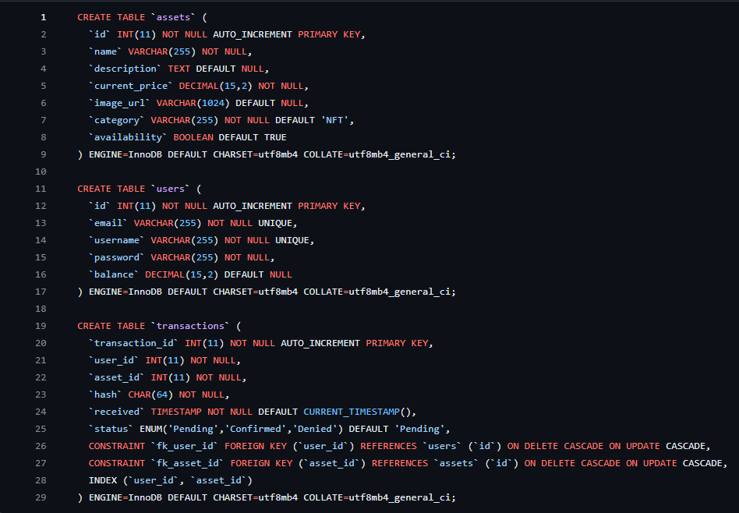

There are 3 table in this database “users”, “transaction and “assets”. For creating account purpose, this table will store username, email and password. In user account, wallet’s balance will be stored. The transactions table serves as a pivotal component for tracking user interactions with assets. It records details such as the transaction identifier “transaction_id”, the involved user “user_id”, the asset in question “asset_id”, a hash referencing the transaction, timestamp of receipt “received”, and the status of the transaction (status). Furthermore, foreign key constraints (“fk_user_id” and “fk_asset_id”) have been established to maintain referential integrity with the users and assets tables, respectively, ensuring that valid users and assets are associated with transactions. This comprehensive schema design not only facilitates user account creation and management but also enables accurate tracking and auditing of transactions, fostering a robust and secure database environment.

## *API Design*

We implement JSON-RPC over HTTP. JSON-RPC (Remote Procedure Call) is a lightweight remote procedure call protocol encoded in JSON (JavaScript Object Notation). It is commonly used for communication between a client and a server over a network. In the context of Ethereum and the ‘geth’ client, JSON-RPC is used to interact with the Ethereum blockchain.

Guild line:

Endpoint:

1. User management:
   * Endpoint: ‘/user’

* ‘GET’: Retrieve user information
* ‘POST’: Create new user
* ‘PUT’: Update user information
* ‘DELETE’: Delete user

1. Asset management:
   * Endpoint: ‘/asset’

* ‘GET’: Retrieve asset information
* ‘POST’: Add asset user
* ‘PUT’: Update asset information
* ‘DELETE’: Delete an asset

1. Transaction management:
   * Endpoint: ‘/transaction

* ‘GET’: Retrieve transaction information
* ‘POST’: Initiate a new transaction.
* ‘PUT’: Update transaction status.
* ‘DELETE’: Cancel a transaction.

# Refences*:*

Krunoslav, R. (2022). Blockchain in Sports Industry: Best Use Cases

Joshua Bernstein (2018). Smart Contract Integration in Professional Sports Management: The Imminence of Athlete Representation

Swan, M. (2015). Blockchain Technology: Principles and Applications

Alchemy (2022, June 14). How to build an NFT Marketplace from Scratch - Solidity and IPFS | Road to Web3. Retrieved from <https://www.youtube.com/watch?v=y6JfVdcJh1k>

freeCodeCamp.org (2022, May 27). Learn Blockchain, Solidity, and Full Stack Web3 Development with JavaScript – 32-Hour Course. Retrieved from [(35) Learn Blockchain, Solidity, and Full Stack Web3 Development with JavaScript – 32-Hour Course - YouTube](https://www.youtube.com/watch?v=gyMwXuJrbJQ&t=2357s)

Dapp University (2022, March 12). Code an NFT Marketplace like OpenSea Step-by-Step [ERC-721, Solidity]. Retrieved from <https://www.youtube.com/watch?v=2bjVWclBD_s>

Daulat Hussain (2022, September 25). Build Your First Full Stack NFT Marketplace On Ethereum With React Js | Include 12 Pages | 19 Hours. Retrieved from [Build Your First Full Stack NFT Marketplace On Ethereum With React Js | Include 12 Pages | 19 Hours (youtube.com)](https://www.youtube.com/watch?v=S3jJtGYI18E&t=28s)

Moralis (2023, February 4). Build A Web3 DEX | FULL COURSE | React, Node, Moralis, 1Inc. Retrieved from [(35) Build A Web3 DEX | FULL COURSE | React, Node, Moralis, 1Inch - YouTube](https://www.youtube.com/watch?v=t8U7GRrlYW8&t=264s)